Project Design Phase
Solution Architecture
Date | 02 October 2026
Team ID | SWTID-2026-9699
Project Name | LegalEase – AI-Powered Legal Document Generator
Maximum Marks | 4 Marks

Solution Architecture:
LegalEase uses a modular web application architecture to help users generate an AI-assisted first draft of a legal document. The system consists of a Streamlit frontend, a FastAPI backend, a Gemini generation service, and a document-formatting service. The frontend collects the user's document details and displays the generated draft. The backend validates and routes generation requests, while the service layer communicates with Google Gemini and prepares downloadable document files.
Architecture and Data Flow Diagram:
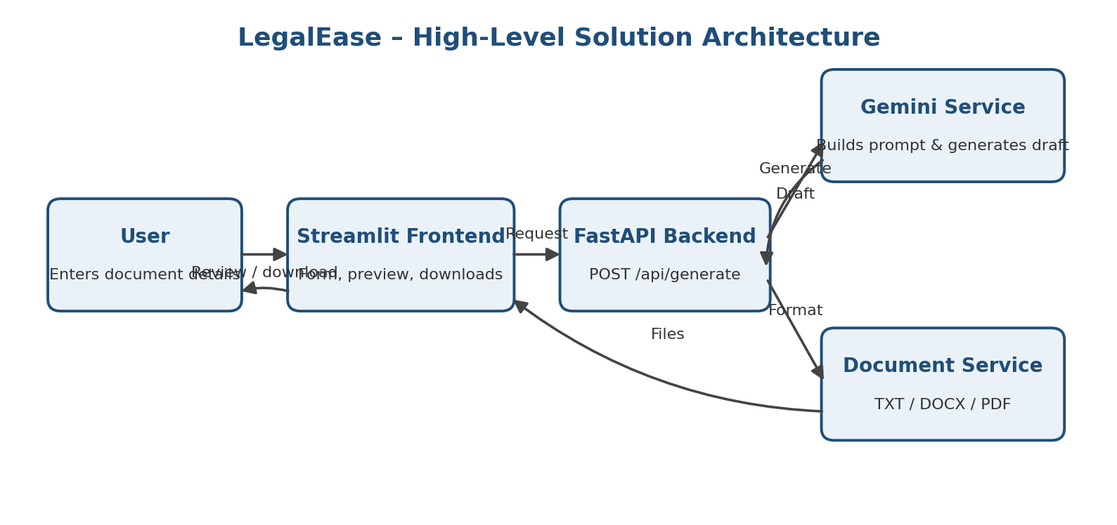
Figure 1: High-level architecture and data flow of the LegalEase application
Component Description:
1. User / Input The user selects a document type and enters the parties and terms. The effective date and brand name are optional inputs.
2. Streamlit Frontend Provides the web interface, document-type selector, input fields, generation action, generated-text preview, and TXT, DOCX, and PDF download buttons.
3. FastAPI Backend Creates the API application and exposes the POST /api/generate endpoint. The route receives a DocumentRequest, calls the document-generation service, and returns a DocumentResponse. Root and health endpoints are also defined.
4. Gemini Generation Service Builds the prompt from the user-provided details and calls Google Gemini using the Google GenAI SDK. The supplied implementation defaults to gemini-2.5-flash; GEMINI_MODEL can override it, and the API key is read from GEMINI_API_KEY.
5. Document Formatting Service Normalizes document text and prepares the generated content for TXT, DOCX, and PDF downloads.
Data Flow:
User enters document details → Streamlit collects the inputs → FastAPI receives the generation request → the Gemini service prepares the prompt and generates a first draft → the document service formats the content → the frontend displays the draft and offers TXT, DOCX, and PDF downloads.
Security and Usage Note:
The Gemini API key should be configured securely through the GEMINI_API_KEY environment variable and must not be exposed in source code or demonstrations. LegalEase generates a first draft only; it does not verify legal correctness or jurisdiction-specific compliance. The generated document should be reviewed by a qualified legal professional before use.
Team ID: SWTID-2026-9699 | LegalEase

